2009-2019 SPTRA 2009-2019
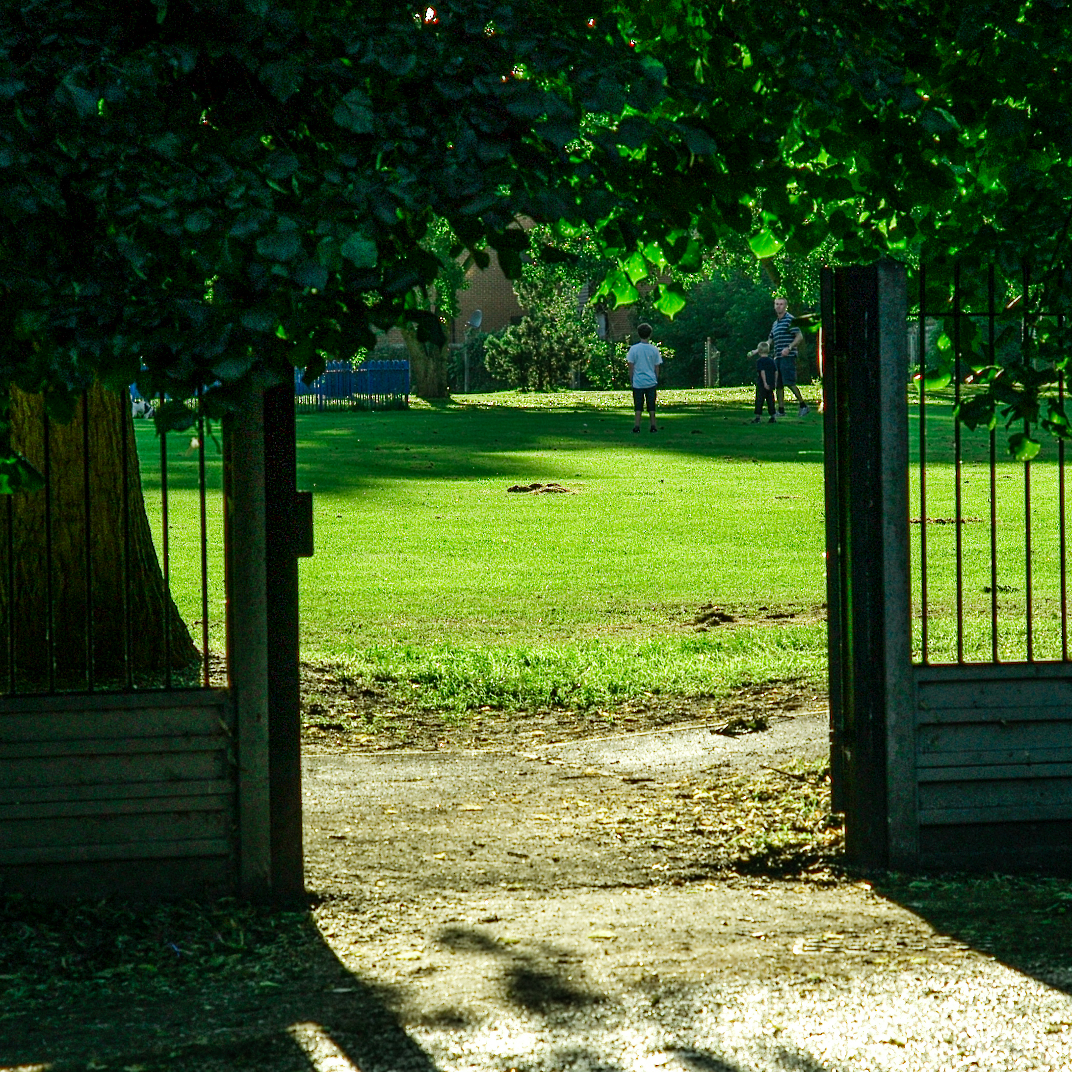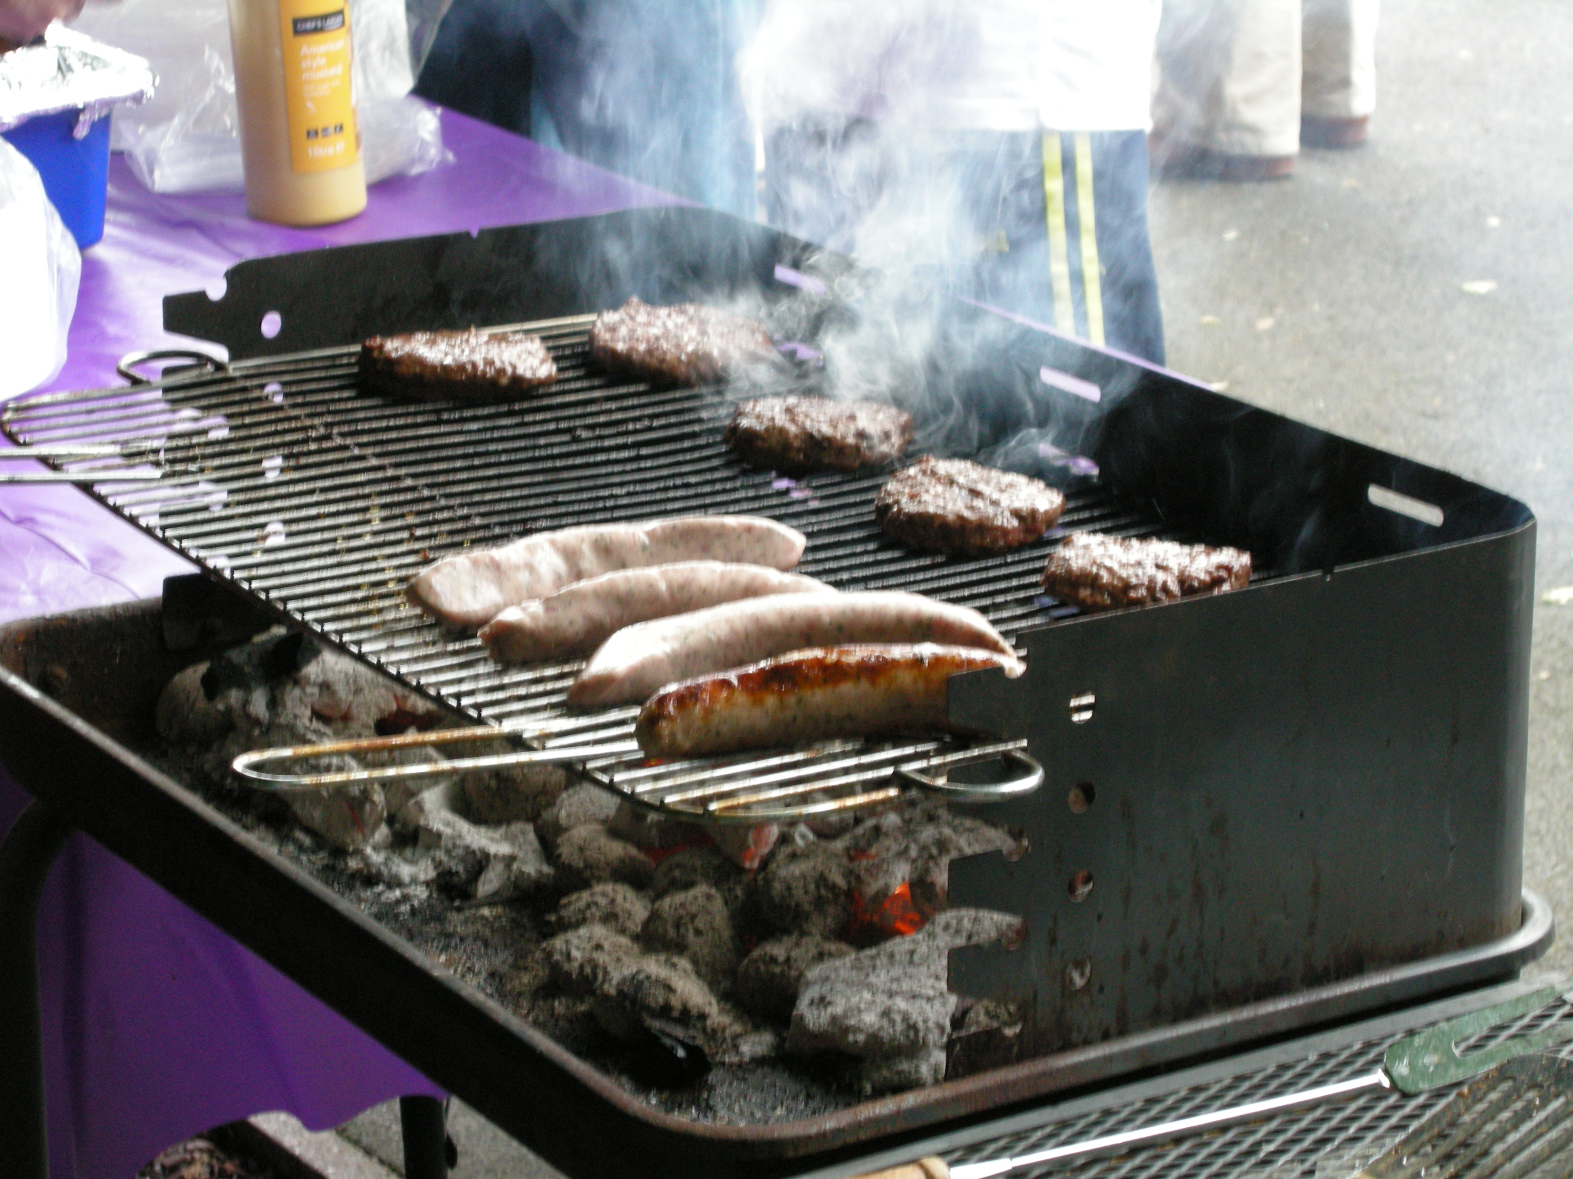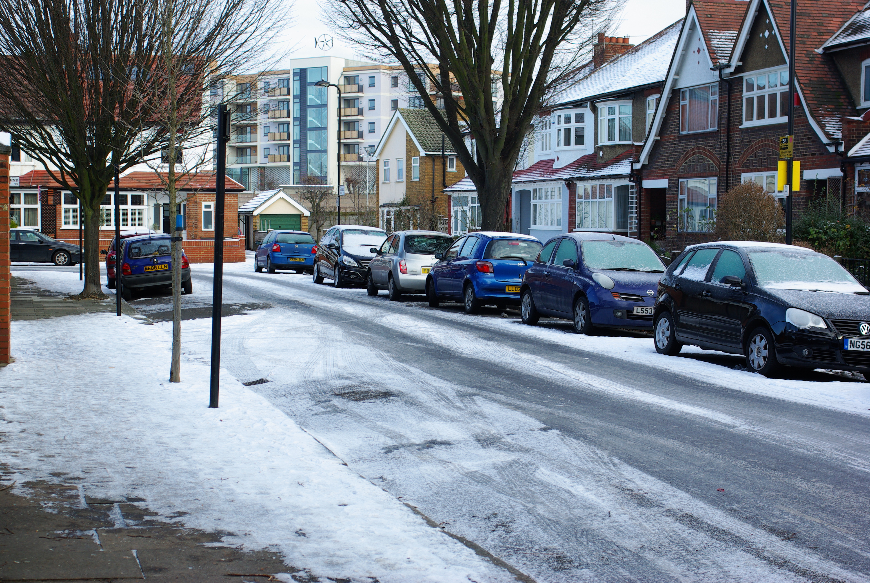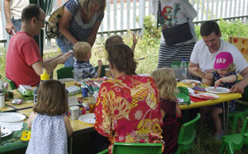
2009-2019 SPTRA 2009-2019
http://www.southfieldparktriangle.org/index.htm

2009-2019 SPTRA 2009-2019

SPTRA 10th AGM
Rugby Road Scout Hut

Saturday May 11th 2019

2009-2019 SPTRA 2009-2019
You are our community
SPTRA engagement
Social activities  - Quiz nights  - SPTRA General Meetings  - Xmas Breakfast - evening meetings + wine  - Summer Parties and raffle  - Park biodiversity Masterclasses  News Updates and Safety  - Reaching 300+ emails  - SPTRA website  - Neighbourhood Watch and OWL  - Security alerts – RING doorbell offers  - Scams alerts  - Police meetings and Regular SNT updates  Attendance and Representation @  - Ward Forums & Councillor Surgeries  - Police Ward Panel  - Safer Neighbourhood Board  - Southfield Neighbourhood Watch  - Ealing Council Meetings  - Meetings with MP’s | Engagement  - Some you win!  - Storm tanks  - New trees/trimming and cutting  - Our park  - Lighting the paths  - New Exercise equipment  - CPZ Consultation  - 20mph scheme – & part of CRW  - Improving our Scout Hut  - 20 more parking spaces  - Some you don’t (yet)  - Shared spaces & Wheelie bins  - Renaming the Ward…?  - CCTV  - Dockless bikes  - Freshways Dairy  - Deliveroo (not yet)  - Still thinking  - Conservation area
Community achievements

Agenda
- Welcome
- Accounts of SPTRA – 2018 to 2019
- Election of the committee
- Review and Preview
      - Bumper Summer Party - anniversary

A toast

Meeting closes 11.10

