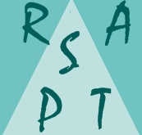
See you all at the Summer Party
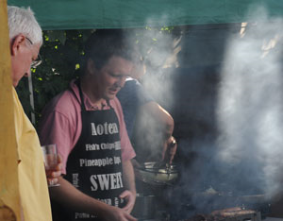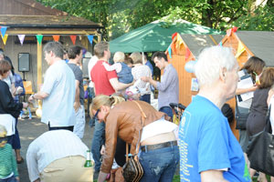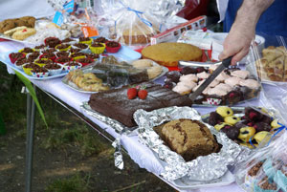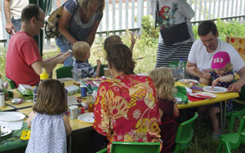
Saturday June 20th 3.00pm
http://www.southfieldparktriangle.org/index.htm

SPTRA 6th AGM
Rugby Road Scout Hut
09.45 – 10.30

Saturday May 9th 2015

SPTRA Summer Party
Saturday June 20th 3.00pm onwards

SPTRA Activities – making a difference
Social and fun activities  - Quiz nights  - Festive events  - Book group  - SPTRA General Meetings  - Breakfast meeting and wine evening  - Regular SNT updates  - Summer Party & special Children`s  events and secure area  News and Updates  - Regular updates – to 300 email addresses  - SPTRA website – at your fingertips  - Security notifications and alerts  - Police meetings  - Meeting/ dialogue with MP`s  - Meeting/dialogue with LBE  Attendance @  - Ward Forums  - Ward Surgery  - NHW Meetings as SPTRA and NHW Reps  - Ward Panel | Lobby  - Thames Tunnel – smell and noise  - Public Meetings 120 people  - LBE regulatory team  - Involvement with MPs  - Alley Gates  - 9 successful schemes  - Trees  - New ones/roots/trimming and cutting  - Southfield Park  - 2 successful lighting projects  - Exercise equipment  - Project park improvements  - Planning issues  - Regular involvement and campaigns  - Security  - Specific improvements – alleys  - Police liaison  - SPTRA neighbourhood watches  - CPZ consultation  - We won 2nd time of trying  - Southfield 20mph scheme  - Double Yellow Lines  - More spaces

Agenda
- Welcome
- Accounts of SPTRA – 2014 to 2015
- Election of the committee
- Keeping you posted - SPTRA updates
    - Wheelie Bins
    - Parking – Double yellow lines changes
    - Thames Tunnel
    - Summer Party and next meeting
    - Door knocking
- Meeting closes 10.30

